THE LEGION OF MARY ARLINGTON REGIA
INVITES YOU TO A MASS TO COMMEMORATE
AND PRAY for the BEATIFICATION of
Frank Duff
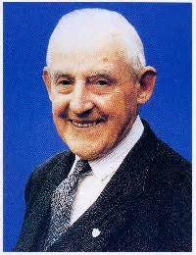
Tuesday, November 8, 2022
6:30pm Holy Rosary
7:00 pm Holy Mass
Our Lady of Lourdes Catholic Church
830 23rd. Street South, Arlington, VA 22202
For inquiry, call:
Sr. Virginia Pierson (703) 915-1318
Sr. Vivian Moran (703) 888-8196
Sr. Maureen Earner (703) 622-9293
Light refreshment to follow at the hall. Regia will take care of this

