What is Forty Hours?
“Lord, teach us to pray” (Luke 11:1)
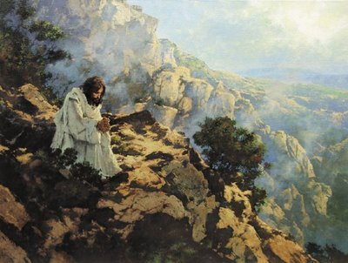

Forty Hours Devotion is a mini-retreat for the whole parish. Its main feature is prayer and meditation before the Blessed Sacrament, which is “the source and summit of the Christian life.” Forty Hours creates a continuous “sacrifice of praise” that flows from the Mass.

The Mass is our most important act of worship because it unites our lives to Christ’s death and resurrection (the Paschal Mystery). The Mass makes our lives a continuous offering to the Father through the death and resurrection of Jesus. All prayer flows from the sacrifice of the Mass. In other words, prayer and meditation outside of Mass form a continuous “sacrifice of praise” that is vital to our relationship with God and one another. Charity is the fruit of prayer.

Why “forty” hours? In the Bible, “forty” signifies a sacred time. Rains fell for 40 days and nights in the time of Noah. The Israelites journeyed 40 years in the desert after fleeing from Egypt. Moses was twice on Mount Sinai for 40 days, receiving the Covenant from God. The prophet Elijah journeyed 40 days and nights to Mount Horeb (Sinai), where he prayed in a cave. Jesus fasted and prayed in the wilderness for 40 days after his Baptism. There were 40 hours between Christ’s burial and resurrection. Forty Hours Devotion connects us to these sacred events, again forming a “continuous sacrifice of praise.”

Forty Hours Devotion begins with a Solemn Mass of Exposition of the Blessed Sacrament. The Blessed Sacrament remains exposed on the altar in a monstrance for the next couple of days. During this time, the Sacrament is reposed during scheduled daily Masses and exposed again after Masses. The faithful are invited to read the Bible and meditate in the presence of the Sacrament during this sacred time. Forty Hours Devotion will conclude with a Solemn Mass at 5:30 PM on February 11, the Feast of Our Lady of Lourdes, followed by a procession of the Blessed Sacrament and Benediction.

